Continue

Workshop #6

Flutter Developer Bootcamp

# **Purpose**

This workshop demonstrates the use of the continue statement within a for loop.

**Problem**

In the given workshop defines a main function where a for loop iterates through numbers from 0 to 6. During each iteration, it checks if the current number i equals 3. If true, it prints a message indicating that i is skipped but continues to the next iteration using continue. For all other values of i, it simply prints the value. As a result, when executed, the output will display the numbers from 0 to 6, except for the number 3 which is skipped with the accompanying message. You need to make the number 5 skipped with accompanying message.

**How to Solve**

1. Checkout the workshop from Git Repo:

git clone -b <user-branch> <repo-URL>

1. Open the root folder inside VS Code
2. Open the root folder in terminal
3. Run the command dart run filename.dart
4. The Dart program defines a main function where a for loop iterates from 0 to 6.
5. During each iteration, it checks if the current value i equals 5 using an if statement.
6. If i equals 5, it prints 'Skipped 5 but loop continues' and skips to the next iteration using continue.
7. For all other values of i (0, 1, 2, 3, 4, 6), it simply prints the value of i.
8. Go To File: <specific-file--method> à <method-name>, implement your logic.

**You will Achieve**

When you complete this workshop you will learn the following:

**Methods and Functions Used:**

* **Main Function (main):**
* Entry point of the Dart program.
* Responsible for starting the execution of the program.
* **For Loop:**
* Iterates through numbers from 0 to 6 (for (int i = 0; i <= 6; i++)).
* Executes a block of code repeatedly until a specified condition (i <= 6) is no longer true.
* **Conditional Check (if statement):**
* Checks if the current value of i equals 5 (if (i == 5)).
* Controls whether a block of code is executed based on the condition provided (i == 5).
* **Print Function (print()):**
* Outputs a message or a value to the console.
* Used to display the current value of i or a specific message when i equals 5 (print('Skipped $i but loop continues')).
* **Continue Statement (continue):**
* Skips the remaining code in the current iteration of a loop (continue;).
* Causes the loop to proceed to the next iteration without executing the subsequent statements in the loop body for the current iteration.

# **Screenshots**

## **Before implementation (without making number 5 skipped)**

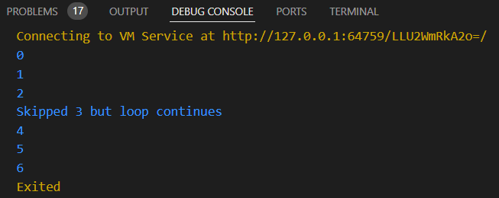

## **After implementation (with making number 5 skipped)**

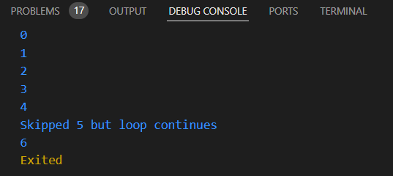

# **How to submit your workshop**

Push your project back to the same git branch using command:

<command name>

# **Happy Coding!**